DATA SCIENCE INTERSHIP REPORT(TASK1)
Cognifyz Technologies – Data Science Internship
Task1:Data Exploration and Preprocessing
Name: Pranav KS
Internship Role: Data Science Intern
Level= Level1
Task: Task1-Data Exploration and Preprocessing

Objective
The objective of this task is to explore and preprocessing the restaurant dataset. The
Analysis focuses on understanding the structure of dataset ,identifying any missing values, there is any data types are changed to converting if necessary. And analysing
The distribution of the target variable, Aggregate rating. The task also examines
Whether the rating distribution is uneven across the different rating values.

Dataset Overview
The dataset loaded into a pandas DataFrame and examined to understand its structure.
The dataset contains 9551 rows and 21 columns. The column names were also examined
To understand the different attributes available for analysis.

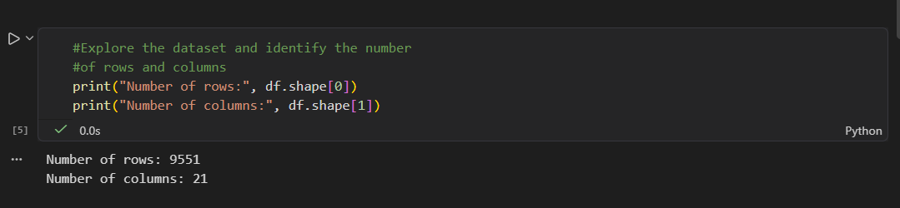

Data Type Analysis
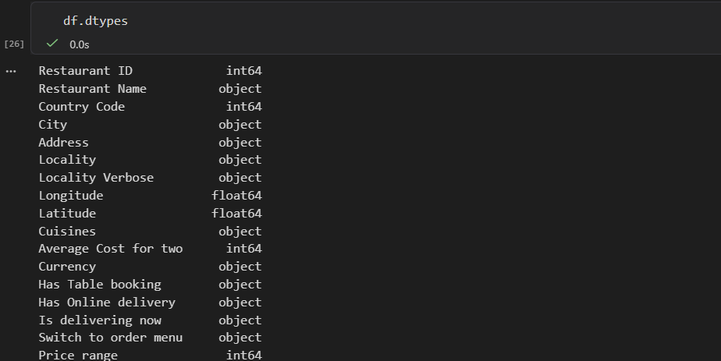

The data types of all columns were examined using pandas dtypes property.
This step was performed to identify columns whose data types may require
Conversion before further analysis.

No unnecessary data type conversion were performed because the columns were already stored in suitable formats for analysis.

MISSING VALUE ANALYSIS

Missing values were identified using the isnull().sum() method. The columns containing missing values were examined before deciding how they should be handled.

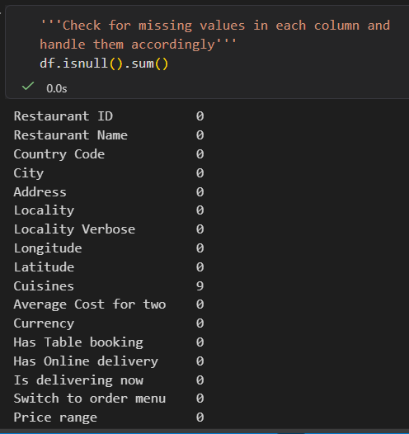

In this report there is no null value .so there no need to remove or fill the

Aggregate Rating distribution

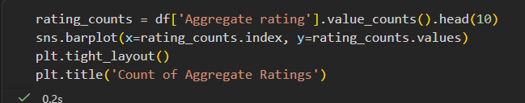

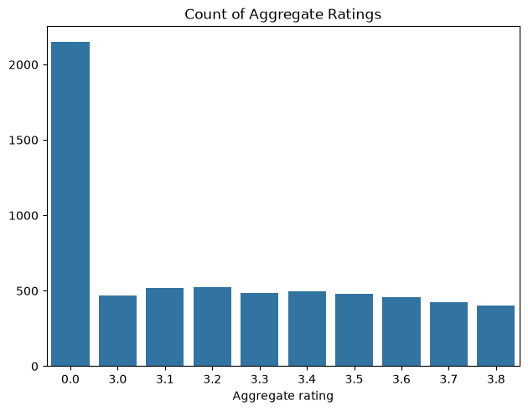

The distribution of the Aggregate rating variable was analyzed using frequency counts and a bar chart. The ratings are not evenly distributed across the dataset. The 0.0 rating category has the highest frequency, with 2,148 records, while the other rating values occur at considerably lower frequencies.

Rating Distribution and Imbalance
The Aggregate rating distribution is highly uneven, with the 0.0 rating occurring much more frequently than the other individual rating values. Therefore, the distribution should be considered imbalanced or uneven. Since Aggregate rating is a numerical rating variable rather than a traditional categorical classification target, this observation is described as an uneven rating distribution rather than a formal classification-class imbalance.

Preprocessing summary

The dataset was inspected for its structure, data types, and missing values. Appropriate preprocessing steps were applied based on the identified data-quality issues. The Aggregate rating variable was also analyzed using frequency counts and visualization to understand its distribution.

Conclusion

The dataset was successfully explored and prepared for further analysis. The structure and data types of the dataset were examined, and missing values were identified and handled where necessary. The distribution of Aggregate rating was also analyzed. The results showed that the rating values are unevenly distributed, with 0.0 having the highest frequency among the individual rating values. These findings provide a foundation for the remaining data analysis tasks

